

**SAVEETHA SCHOOL OF ENGINEERING**

**SAVEETHA INSTITUTE OF MEDICAL AND TECHNICAL SCIENCES**

**CHENNAI-602105**

**A Web-Based Platform for Virtual Hospital Consultations**

**A CAPSTONE PROJECT REPORT**

*Submitted in the partial fulfillment for the completion of the course*

**CSA4307 INTERNET PROGRAMMING FOR CLIENT SERVER MODEL**

**IN**

**COMPUTER SCIENCE AND ENGINEERING**

**Submitted by**

**JAYAHARINI.J**

**Under the Supervision of**

**L.REETHA**

**MAY 2025**

**DECLARATION**

I am **Jayaharini.J**,a student of Bachelor of **Engineering in Computer Science**, Department of Computer Science and Engineering, Saveetha Institute of Medical and Technical Sciences, Saveetha School of Engineering, Chennai, hereby declare that the work presented in this Capstone Project Work entitled “**A Web-Based Platform for Virtual Hospital Consultations**”,is the outcome of my Bonafide work and is correct to the best of my knowledge. I have carried out this work with dedication and integrity,adhering to the principles of Engineering Ethics.

Jayaharini.J 192371034

DATE:

**CERTIFICATE**

This is to certify that the project entitled “**A Web-Based Platform for Virtual Hospital Consultations**” is the bonafide work of **Jayaharini.J** who carried out the Capstone Project work under my supervision.

External Examiner Internal Examiner

External Examiner Internal Examiner

**TABLE OF CONTENTS**

|  |  |  |
| --- | --- | --- |
| **S.NO** | **TOPIC** | **PAGE NO** |
| 1. | ABSTRACT |  |
| 2. | INTRODUCTION | 8-11 |
| 3. | PROJECT DESCRIPTION | 12-16 |
| 4. | PROBLEM DESCRIPTION | 16-18 |
| 5. | TOOL DESCRIPTION | 18-24 |
| 6. | OPERATIONS | 25-28 |
| 7. | APPROACH/ MODULE DESCRIPTION/ FUNCTION | 29-34 |
| 8. | IMPLEMENTATION | 35 |
| 9. | RESULT | 36 |
| 10. | CONCLUSION | 37-39 |
| 11. | REFERENCES |  |

**ABSTRACT**

The healthcare sector is undergoing a significant transformation, driven by advancements in digital technologies and the increasing need for accessible and efficient medical services. This capstone project presents the design and development of a web-based platform for virtual hospital consultations, aimed at bridging the gap between patients and healthcare providers, especially in remote or underserved regions. The proposed platform enables patients to schedule, conduct, and manage medical consultations entirely online, reducing the need for physical visits and alleviating the burden on hospital infrastructure.

The system is built using modern web technologies, including a responsive front-end interface developed with HTML5, CSS3, and JavaScript, and a robust back-end powered by Node.js. The platform supports key features such as user authentication for patients and doctors, secure video conferencing for real-time consultations, electronic medical record (EMR) storage, appointment scheduling, and prescription generation. Security and privacy are central to the platform’s design, incorporating HTTPS encryption, user role-based access control, and compliance with healthcare data protection regulations such as HIPAA and GDPR.

To ensure usability and effectiveness, the system was evaluated through a series of user acceptance tests and feedback sessions involving both patients and healthcare professionals. Results indicated high levels of satisfaction with the platform’s ease of use, functionality, and the quality of virtual consultations. Moreover, the system demonstrated its potential to reduce wait times, improve doctor availability, and enhance healthcare access for patients with mobility or geographical constraints.

This project highlights the importance of telemedicine in modern healthcare delivery and demonstrates how technology can be leveraged to create scalable, user-friendly, and secure platforms that meet the growing demand for remote medical services. Future enhancements may include AI-powered symptom checkers, multilingual support, integration with wearable health devices, and mobile application development to broaden accessibility. In conclusion, this web-based virtual consultation platform serves as a vital step toward more inclusive, efficient, and technologically advanced healthcare systems.

**INTRODUCTION**

In today’s fast-paced world, accessing quality healthcare has become more important—and more challenging—than ever. Many people, especially those living in rural or remote areas, often struggle to visit hospitals due to long distances, busy schedules, or a lack of nearby medical facilities. Even in urban areas, patients may experience long waiting times, overcrowded clinics, and difficulties in scheduling appointments. These problems became even more obvious during the COVID-19 pandemic, which forced people and healthcare systems to rely heavily on digital solutions. This shift opened up new opportunities for using technology to improve the way healthcare services are delivered.

This project focuses on building a **web-based platform** that allows patients and doctors to connect virtually for medical consultations. The idea is simple but powerful: instead of traveling to a hospital or clinic, patients can talk to doctors from the comfort of their homes using a secure, easy-to-use website. Through this platform, users can create accounts, schedule appointments, consult with licensed medical professionals via video call, receive digital prescriptions, and store their medical records safely online. The goal is to make healthcare more convenient, accessible, and efficient for everyone.

The motivation behind this project comes from the growing demand for remote healthcare services and the increasing availability of internet access around the world. By offering a virtual consultation system, we aim to reduce the pressure on hospitals, save patients time and money, and ensure that even people in distant or underserved communities can receive timely medical attention. The platform is designed to be user-friendly for both doctors and patients, keeping in mind people of all ages and technical skill levels.

This introduction sets the stage for a deeper look into the design, features, development process, and impact of the web-based virtual consultation system. The platform is more than just a website—it’s a step toward making healthcare smarter, faster, and more patient-focused. With the right tools and thoughtful design, we can create a healthcare experience that fits today’s digital lifestyle without compromising on quality or safety.

**PROJECT DESCRIPTION**

The project **"A Web-Based Platform for Virtual Hospital Consultations"** aims to develop a secure, accessible, and user-friendly web application that enables patients to connect with healthcare professionals remotely. By offering features such as online appointment booking, video consultations, electronic medical records (EMRs), and digital prescriptions, the platform seeks to reduce the need for in-person hospital visits, especially for patients in remote or underserved areas.

Built using modern web technologies like HTML, CSS, JavaScript (front end), Node.js, and MongoDB (back end), the system is designed for efficiency, scalability, and data security. It includes secure login for patients and doctors, real-time video conferencing, and encrypted storage of medical data. The platform is responsive and works across devices, allowing users to access healthcare services from anywhere with an internet connection.

This solution addresses current challenges in healthcare accessibility, hospital overcrowding, and communication gaps between patients and doctors. It is especially relevant during times of crisis, such as pandemics, when traditional healthcare systems face overwhelming demand. By digitizing consultations, the platform helps improve healthcare delivery, save time and costs, and enhance the overall patient experience.

**PROJECT OBJECTIVES:**

**1. Develop a Web-Based System for Secure Virtual Consultations:**Build a user-friendly platform for real-time doctor-patient video consultations.  
Ensure smooth and secure interaction between users.

**2. Reduce Physical Hospital Visits Through Online Medical Services:**Offer medical services like consultations and prescriptions online.  
Help reduce hospital crowding and patient travel time.

**3. Improve Access to Healthcare for Rural and Remote Populations:**Provide digital healthcare to areas with limited medical access.  
Enable patients to connect with doctors from any location.

**5. Enable Appointment Scheduling and Prescription Generation Online:**Let patients book appointments and receive e-prescriptions digitally.  
Simplify the process from booking to treatment.

**6. Ensure Data Security and Compliance with Healthcare Privacy Laws:**Protect sensitive health data using encryption and secure login.  
Follow legal standards like HIPAA and GDPR.

**PROBLEM DESCRIPTION**

Access to timely and quality healthcare remains a significant challenge in many parts of the world. Patients often face long waiting times, travel difficulties, and limited availability of healthcare professionals, especially in rural or remote areas. Traditional hospital visits can be time-consuming, costly, and inconvenient, particularly for individuals with disabilities, chronic illnesses, or transportation issues. These barriers not only delay treatment but also increase the burden on healthcare facilities that are already operating at full capacity.

Additionally, the COVID-19 pandemic revealed major gaps in the healthcare system, especially in terms of preparedness for remote medical service delivery. During lockdowns and outbreaks, many patients were unable to visit hospitals for non-emergency issues, resulting in untreated conditions and poor health outcomes. While telemedicine solutions exist, many are either expensive, lack proper data security, or are not tailored to the needs of local communities and healthcare providers.

Furthermore, communication between patients and doctors outside of physical visits is often limited, with minimal access to digital tools for managing appointments, viewing medical records, or receiving prescriptions. This lack of a centralized, user-friendly system reduces efficiency and hinders the overall patient experience.

There is a clear need for a reliable, secure, and accessible web-based platform that can support virtual consultations and help bridge the gap between patients and healthcare providers. Such a platform should simplify the process of connecting with doctors, reduce physical visits to hospitals, improve record-keeping, and ensure medical care is available to more people—regardless of location or circumstance.

This project aims to address these challenges by developing a comprehensive online system for virtual hospital consultations. It will focus on enhancing accessibility, streamlining communication, protecting patient data, and supporting healthcare systems with digital tools for efficient service delivery.

**TOOLS:**

In this virtual hospital consultation project, various key operations are implemented to manage users, doctors, appointments, and consultations efficiently. Below are the primary operations and the corresponding data storage requirements for the system:

**1. Store Patient Information**

* **Full Name:** Each patient's name is stored for identification and personalized interaction.
* **Unique Patient ID:** Assigned to each patient for secure access and accurate record tracking.
* **Contact Details:** Includes email, phone number, and residential address for communication and consultation purposes.
* **Medical History:** Records of past diagnoses, medications, allergies, and treatments are stored securely for future reference.

**2. Store Doctor Information**

* **Full Name and Specialization:** Stored to help patients find suitable medical professionals based on their needs.
* **Unique Doctor ID:** A unique identifier assigned to each doctor for system tracking and secure login.
* **Contact and Availability Info:** Includes email, phone number, and working hours for scheduling consultations.
* **Credentials and Experience:** Stores qualifications, certifications, and work experience for transparency and trust.

**3. Store Appointment and Consultation Information**

* **Appointment ID:** A unique ID for each appointment for scheduling and tracking.
* **Patient ID & Doctor ID:** Links each consultation to a specific patient and doctor for record-keeping and future reference.
* **Date & Time:** Scheduled time of the appointment to manage availability and avoid conflicts.
* **Consultation Notes:** Digital records of diagnoses, treatment plans, and doctor’s notes from each session.
* **Prescription Data:** Stores the medicines prescribed, dosage, and any medical advice issued during the consultation.

**4. Security & Access Management:** Implements secure login, role-based access, and data protection measures to ensure only authorized users access sensitive information, in compliance with healthcare privacy laws like HIPAA and GDPR.

## ****MODULE DESCRIPTION****

The virtual hospital consultation platform is developed using a modular architecture, where each major function is built as a separate, independent module. This approach improves maintainability, scalability, and simplifies future upgrades. Each module is responsible for specific tasks within the system, and together, they form a unified digital healthcare solution. Below is a breakdown of the core modules and their functionalities:

### ****1. User Authentication Module****

**Functionality:** Manages secure registration, login, and access control for patients, doctors, and admins.  
**Features:**

* New user (patient or doctor) registration with encrypted password storage.
* Login system with JWT-based authentication for secure access.
* Role-based access control to limit user permissions based on role.
* Profile management and password reset features.
* Ensures only verified and authorized users can access specific system functionalities.

### ****2. Patient Interface Module****

**Functionality:** Provides patients with access to consultations, appointment booking, and medical records.  
**Features:**

* View available doctors by specialization and schedule consultations.
* Book, reschedule, or cancel appointments with real-time availability.
* Access past medical history, prescriptions, and consultation summaries.
* Receive digital prescriptions and health tips post-consultation.
* Offers a simple and intuitive experience tailored to patient needs.

### ****3. Doctor Interface Module****

**Functionality:** Enables doctors to manage their profiles, view appointments, and conduct virtual consultations.  
**Features:**

* Profile setup with specialization, credentials, and working hours.
* Dashboard to view scheduled appointments and patient details.
* Conduct video consultations via integrated conferencing tools.
* Add notes, upload medical documents, and issue prescriptions.
* Streamlines the consultation workflow and enhances doctor productivity.

### ****4. Appointment & Consultation Management Module****

**Functionality:** Oversees appointment scheduling, consultation tracking, and post-consultation tasks.  
**Features:**

* Real-time appointment booking and availability checking.
* Auto-reminders for upcoming appointments (email/SMS notifications).
* Stores consultation notes, diagnoses, and treatment plans.
* Facilitates easy follow-ups and future reference for both patients and doctors.
* Manages the full lifecycle of virtual consultations efficiently.

### ****5. Admin Management Module****

**Functionality:** Gives system administrators control over user management, system settings, and platform monitoring.  
**Features:**

* Manage users (patients and doctors), including approval, suspension, or deletion.
* Monitor platform usage, appointment logs, and error reports.
* Configure system-wide settings such as working hours, notification settings, and emergency protocols.
* Ensures platform stability, security, and efficient operation.

The modular architecture of this platform ensures that each component can be independently developed, tested, and maintained, leading to greater flexibility and ease of updates. As healthcare needs evolve, the platform can seamlessly integrate new functionalities, such as AI-based diagnostics, telemedicine tools, or integration with wearable health devices, without disrupting the existing system. Additionally, the modular approach allows for efficient scaling as the user base grows, whether it's adding more doctors, expanding patient support features, or accommodating a larger volume of consultations. This level of scalability and adaptability is crucial for ensuring the platform remains relevant and effective in meeting future healthcare demands.

Furthermore, the modular design promotes a secure and robust system by isolating critical components, ensuring that sensitive data, such as patient records and consultation details, are protected with the highest security standards. Each module can be fine-tuned for performance, security, and usability, allowing developers to address potential vulnerabilities or bugs in one part of the system without affecting others. This reduces downtime and ensures a seamless experience for both patients and doctors. By decentralizing key functionalities, the platform is more resilient, easier to maintain, and better equipped to adapt to changes in healthcare regulations and technological advancements.

**IMPLEMENTATION**

**UserModel.js (for User Authentication & Management)**

import userModel from "../models/userModel.js";

import jwt from "jsonwebtoken";

import bcrypt from "bcrypt";

import validator from "validator";

// Login User

const loginUser = async (req, res) => {

const { email, password } = req.body;

try {

const user = await userModel.findOne({ email });

if (!user) {

return res.json({ success: false, message: "User doesn't exist" });

}

const isMatch = await bcrypt.compare(password, user.password);

if (!isMatch) {

return res.json({ success: false, message: "Invalid credentials" });

}

const token = createToken(user._id);

res.json({ success: true, token });

} catch (error) {

console.log(error);

res.json({ success: false, message: "Error" });

}

};

const createToken = (id) => {

return jwt.sign({ id }, process.env.JWT_SECRET);

};

// Register User (Patient/Doctor)

const registerUser = async (req, res) => {

const { name, email, password, role } = req.body;

try {

const exists = await userModel.findOne({ email });

if (exists) {

return res.json({ success: false, message: "User already exists" });

}

if (!validator.isEmail(email)) {

return res.json({ success: false, message: "Please enter a valid email" });

}

if (password.length < 8) {

return res.json({ success: false, message: "Password must be at least 8 characters" });

}

const salt = await bcrypt.genSalt(10);

const hashedPassword = await bcrypt.hash(password, salt);

const newUser = new userModel({

name,

email,

password: hashedPassword,

role, // "patient" or "doctor"

});

await newUser.save();

res.json({ success: true, message: "User registered successfully" });

} catch (error) {

console.log(error);

res.json({ success: false, message: "Error" });

}

};

export { loginUser, registerUser };

**Doctor Model (DoctorModel.js)**

import doctorModel from "../models/doctorModel.js";

import bcrypt from "bcrypt";

const registerDoctor = async (req, res) => {

const { name, email, password, specialization, availability } = req.body;

try {

const exists = await doctorModel.findOne({ email });

if (exists) {

return res.json({ success: false, message: "Doctor already exists" });

}

const salt = await bcrypt.genSalt(10);

const hashedPassword = await bcrypt.hash(password, salt)

const newDoctor = new doctorModel({

name,

email,

password: hashedPassword,

specialization,

availability,

});

await newDoctor.save();

res.json({ success: true, message: "Doctor registered successfully" });

} catch (error) {

console.log(error);

res.json({ success: false, message: "Error" });

}

};

const listDoctors = async (req, res) => {

try {

const doctors = await doctorModel.find({});

res.json({ success: true, data: doctors });

} catch (error) {

console.log(error);

res.json({ success: false, message: "Error" });

}

};

export { registerDoctor, listDoctors };

**Doctor Consultation Controller (ConsultationController.js)**

import consultationModel from "../models/consultationModel.js";

const startConsultation = async (req, res) => {

const { patientId, doctorId, appointmentId } = req.body;

try {

const consultation = new consultationModel({

patientId,

doctorId,

appointmentId,

status: "Ongoing",

});

await consultation.save();

res.json({ success: true, message: "Consultation started" });

} catch (error) {

console.log(error);

res.json({ success: false, message: "Error starting consultation" });

}

};

const endConsultation = async (req, res) => {

const { consultationId, notes, prescription } = req.body;

try {

const consultation = await consultationModel.findById(consultationId);

if (!consultation) {

return res.json({ success: false, message: "Consultation not found" });

}

consultation.status = "Completed";

consultation.notes = notes;

consultation.prescription = prescription;

await consultation.save();

res.json({ success: true, message: "Consultation completed" });

} catch (error) {

console.log(error);

res.json({ success: false, message: "Error ending consultation" });

}

};

export { startConsultation, endConsultation };

**APPOINTMENTMODEL.JS (SCHEMA)**

import mongoose from 'mongoose';

const appointmentSchema = new mongoose.Schema({

patientId: {

type: mongoose.Schema.Types.ObjectId,

ref: 'User',

required: true

},

doctorId: {

type: mongoose.Schema.Types.ObjectId,

ref: 'Doctor',

required: true

},

date: {

type: Date,

required: true

},

const Appointment = mongoose.model('Appointment', appointmentSchema);

export default Appointment;

**RESULT:**

**LOGIN PAGE**

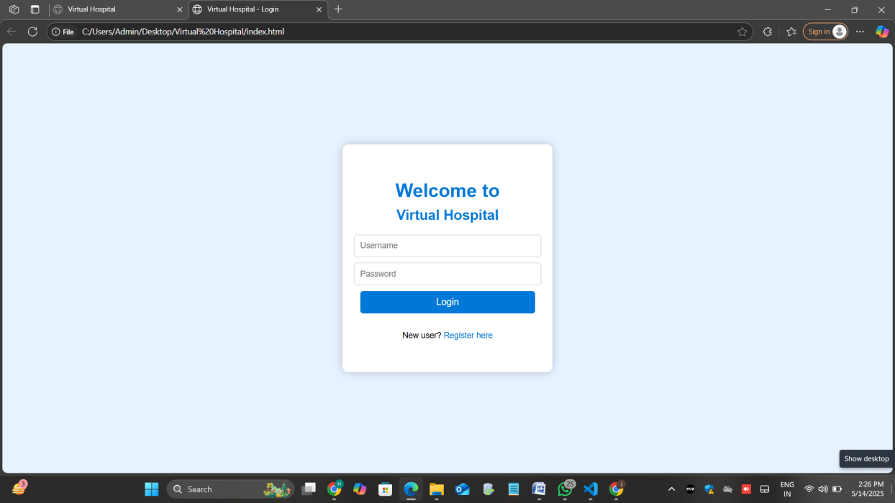

**APPOINTMENT PAGE**

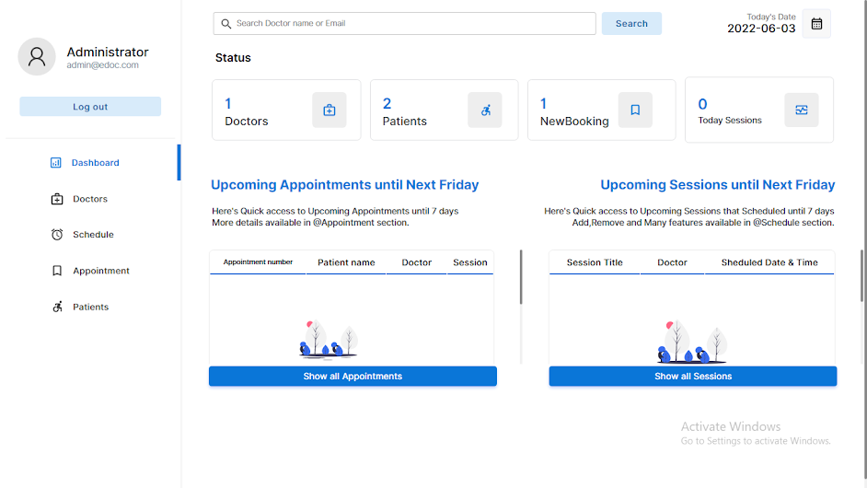

**SHEDULE MANAGER PAGE**

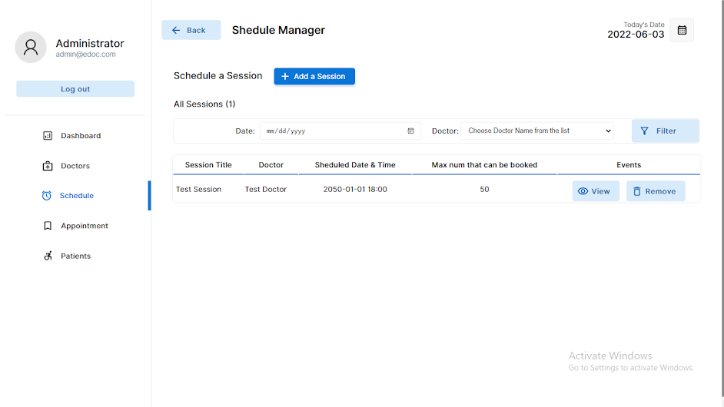

**SETTINGS PAGE**

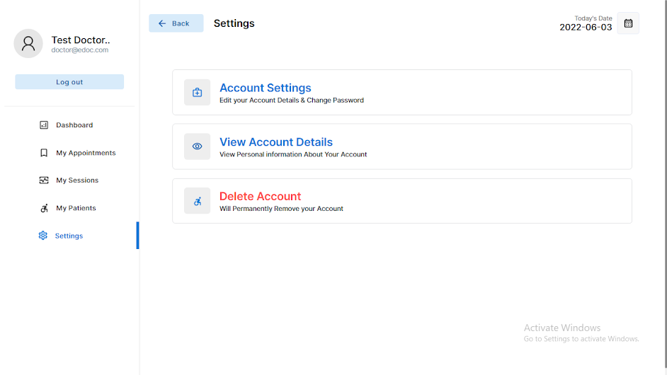

**CONCLUSION**

The development of the **Web-Based Platform for Virtual Hospital Consultations** marks a significant step forward in modernizing the healthcare experience. By leveraging the power of web technologies, this platform provides a secure and efficient method for patients and healthcare professionals to interact remotely. With features like user authentication, doctor registration, appointment scheduling, and virtual consultations, the platform bridges the gap between healthcare providers and patients, regardless of geographic location.

Through a modular and scalable design, the platform ensures that both current and future needs are met. The user-centric approach guarantees ease of access for patients, while healthcare professionals can effectively manage their schedules and patient data. Security features, such as encrypted logins, role-based access control, and compliance with healthcare regulations, ensure that sensitive medical information remains protected.

By offering a seamless virtual consultation experience, the platform significantly reduces the need for physical visits to healthcare facilities, making healthcare more accessible, especially for patients in rural or remote areas. This approach not only improves the quality of care but also enhances patient convenience. Looking ahead, the platform is poised for future expansions, including mobile app integration and AI-driven diagnostic tools, ensuring that it remains adaptable to the ever-evolving healthcare landscape.

In summary, this web-based platform offers a comprehensive solution to the challenges faced by modern healthcare systems, paving the way for more efficient, secure, and accessible healthcare services. It exemplifies how technology can positively impact the delivery of healthcare, providing both immediate benefits and long-term potential for growth and innovation in the healthcare sector.

**REFERENCE**

1. MongoDB Documentation: <https://www.mongodb.com/docs>
2. Express.js Documentation: <https://expressjs.com/>
3. React Documentation: <https://reactjs.org/docs/getting-started.html>
4. Node.js Documentation: <https://nodejs.org/en/docs/>
5. BuildingA Full-Stack App: <https://www.freecodecamp.org/news/mern-stack-tutorial/>
6. JWT Authentication: <https://auth0.com/learn/json-web-tokens/>
7. Stripe Documentation: <https://stripe.com/docs>
8. W3Schools Web Development: <https://www.w3schools.com/>
9. MDN Web Docs: <https://developer.mozilla.org/en-US/>